- An object is launched from a platform that is 80 feet above the ground. The height of the object is a function of time $h\left(t\right)=-16t^{2}+64t+80$, where h is measured in feet and t is time in seconds. If you choose to solve this problem graphically, be sure to support your solution with a sketch or table and the proper labeling of all parts.
  - At what time does the object reach its maximum height?

  - What is the maximum height the ball will reach?

  - For how many seconds, to the nearest hundredth, will the ball be above 125 feet?

- Factor and reduce the following rational expression: $\frac{3x-x^{2}}{9-x^{2}}$

- Write and equation of a parabola with the given characteristics, sketch a graph for full credit:
Focus: (0, 6) directrix: y = -6

- Identify the transformation, in function notation, of a parabola with a vertex of $(-1, 3)$ to a parabola with a vertex of $\left(2, 4\right)$.

- Simplify each expression:
  - $3\sqrt{32}$

  - $\sqrt{-36}$

  - $2\sqrt{-20}$

- Sketch a scatter plot of a linear regression with an r-value close to $-1$.

- Solve the equation using the quadratic formula, express your answer in simplest $a+bi$ form:

$$x^{2}+4x=-5$$

- Factor the perfect square trinomial: $x^{2}-7x+\frac{49}{4}$

- Find the average rate of change over the interval $-2≤x≤2$ for the graph given below.
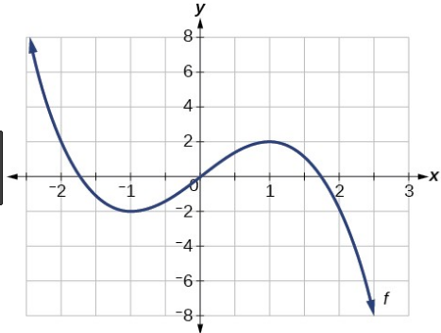

- The expression ${4i}^{3}(2i+3)$is equivalent to what simplified expression?

- Find algebraically, the zeros for $p\left(x\right)=x^{3}+{2x}^{2}-4x-8$.

Sketch the graph $y=p(x)$; using the calculator determine to the nearest hundredth the relative maximum and the relative minimum.

- What is an even function? Draw a sketch of one below:

- If the discriminant is less than zero, sketch a graph the best representation of $y=ax^{2}+bx+c$.

- The graph of $f(x)$ is shown below. What is the remainder when $f(x)$ is divided by:
  - $(x-2)$
  - $(x)$
  - $(x-4)$
  - $(x+3)$

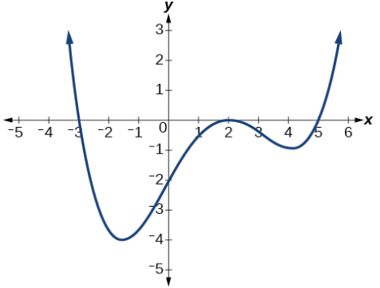

- Solve and check the following rational equation:

$$\frac{5}{x}-\frac{1}{3}=\frac{1}{x}$$

- Using long division, convert $f\left(x\right)=\frac{7x+4}{x-3}$ into the $f\left(x\right)= \frac{a}{x-h}+k$ form, and state the Domain and the Range. Include a sketch of a graph with asymptotes for full credit.

- Solve the non-linear system of equations using and algebraic technique:
$$y+3x=-17$$
$$y=-3x^{2}-30x-71$$

- Determine if $x+3$ is a factor of $-2x^{3}+4x^{2}+8x+10$. Explain your reasoning.

